Submission from the Independent Food Aid Network (IFAN) to the Environment, Food and Rural Affairs Committee (EFRA) on Food Security.
September 2022
The Independent Food Aid Network (IFAN) supports and advocates on behalf of hundreds of independent food aid providers including over 550 independent food banks. Our vision is of a country without the need for charitable food aid where adequate and nutritious food is affordable to all. We advocate for a cash first approach to food insecurity which, through income-based solutions, would eliminate poverty driving the need for charitable food. IFAN has identified at least 1,172 independent food banks currently operating in the UK. This is in addition to hundreds of food banks operated by the Trussell Trust, the Salvation Army, schools, universities, and hospitals as well as thousands of other kinds of charitable food aid organisations such as social supermarkets, food pantries, and soup kitchens.

This submission will address two of the areas in which the Committee is seeking views. Firstly, how the rising cost of living and increasing food prices are affecting access to healthy, nutritious food. And secondly, how the proposals in the Government’s food policy paper will affect access to healthy and nutritious food.

- How are the rising cost of living and increasing food prices affecting access to healthy and nutritious food?

In order to understand how people’s access to healthy and nutritious food has been affected in this current moment of crisis - with the food supply chain disruption caused by factors such as the pandemic, war in Ukraine, and the UK’s relationship with the EU - it’s important to understand the scale of the food insecurity crisis in the UK that predates this. The majority of independent food banks in the UK have only been in existence for the last 12 years and their operations initiated as a response to austerity policy that drastically cut the social security safety net and decimated local crisis support. As a result, even before the Covid-19 pandemic, millions of food parcels have been distributed to people who were unable to afford to buy food for themselves and their families. These individuals’ access to food, irrespective of being healthy and nutritious, has been dependent on charitable food aid organisations as a result of inadequate wages and social security payments.

It is clearer than ever that the increasing reliance of the UK Government on charitable food aid providers to support people living in poverty is unsustainable. IFAN ran a survey of its members in August 2022 on their capacity to cope with an increase in the demand for their services. Nearly 90% of responding organisations saw an increase in demand since April 2022 and 87% reported being impacted by supply issues. As food banks are seeing an increase in need, they are also seeing a fall in food and financial donations - 72% of responding organisations reported that food donation levels have dropped since April. As supply chain issues also threaten the levels of food surplus in the system, on which many charitable food aid organisations rely, there is a danger of severe impact on already fragile charitable groups’ ability to support all who need their services.

Despite shockingly high food bank statistics, we know that most people who are food insecure will not access a food bank. Data from the Department of Work and Pensions’ (DWP) Family Resources Survey (FRS) show that before the Covid-19 pandemic, 43% of UK households on Universal Credit were food insecure. Food Standards Agency (FSA) data show that 15% of people in England, Wales and Northern Ireland were severely and moderately food insecure from April-June 2021, with only 4% using a food bank.

While the majority of people who are food insecure will not use a food bank, even those that do access charitable food aid are not being guaranteed access to healthy and nutritious food. Food banks and charitable food aid organisations are reliant on surplus food, which impacts the likelihood of this being adequate, healthy or nutritious. This reliance on surplus also means there is limited choice and supply available can change week to week. Supply is now far more limited, and 1 in 5 organisations responding to a recent survey run by IFAN of independent food banks, reported that they have had to reduce the size of the food parcels they distribute. The challenges that charitable groups face in transporting, storing and redistributing food, also limits the availability of fresh vs ambient food types. Nutrition requirements will also change from person to person. For example, if a person is disabled their disability may require specific nutrition needs. Without the choice and flexibility afforded to people who are able to buy their own food, meeting these needs is not possible. Disabled experts by experience have spoken to IFAN of accessibility issues and a lack of appropriate choices - especially for people whose disability requires specific dietary requirements. Tailoring food and in-kind support to meet the dietary needs of different groups is an enormous challenge, and charitable food aid groups often make great efforts to enhance the experience of their service users.

Additionally, many service users do not have the capacity to prepare or heat food at home. Therefore many food banks will also offer no-cook food parcels that can be eaten cold, or prepared using only boiling water, further limiting the quality of food available. The current extreme rise in energy prices means a growing number of people have already been put into this situation.

The widening of health inequalities in the UK since the pandemic is well-documented. And this growing chasm has been exacerbated by the normalisation of a charitable food aid system in place of the changes needed to raise people's incomes, relieve the pressure of food insecurity, and ensure a healthy and nutritious diet affordable to all.

- How will the proposals in the Government’s food policy paper affect access to healthy and nutritious food?

The proposals in the Government’s food policy paper will do nothing to stem the growing number of people who are not able to choose and afford healthy and nutritious food due to a lack of income. The policy paper makes no reference to poverty and food bank use that existed long before the Covid-19 pandemic, instead conflating poverty with ‘recent events and manag[ing] the impact of cost-of-living pressures.’ This fails to take into account the failures of the social security system that have seen so many people relying on a second-tier charitable food aid system over the past 12 years.

IFAN agrees with the assertion made by Henry Dimbleby in the National Food Strategy that ‘the true cost of eating healthily should be calculated into benefits payments.’ However the Government’s food policy paper does not make the connection between health inequalities and the low incomes on which people are expected to survive - which all too often is not enough to afford food in the first place. The strategy also speaks to ‘supporting people on lower incomes’ by ‘helping them to enter and progress in work and lead fulfilled lives.’ However, with an increase in the number of people using a food bank who are already in work, without wages being brought in line with the cost of living this is not a guaranteed route out of poverty and food insecurity. This applies to the food industry itself, and while the Government Food Strategy calls for ‘a sufficient, qualified, and well-paid workforce to support every food and drink business’, there are people who are employed by supermarkets and food industry businesses who are regularly supported by independent food banks.

As we head into a winter during which current surges in demand for charitable food aid will inevitably rise yet further, neither the inadequate social security system nor fragile charitable food aid organisations are in a position to meet increasing demand. We need an alternative approach that tackles the root causes of poverty driving the need for charitable food aid including robust preventative measures to stop people from falling into financial crisis in the first place.

To achieve this, IFAN is calling for: a) benefit payments to match the cost of living; b) adequate job security and wages that match the cost of living; c) removal of punitive measures of benefits system including the benefit cap, two child limit, sanctions and No Recourse to Public Funds Status; d) local authority crisis support to be delivered in the form of cash payments; e) well-funded advice and support services.

Appendix:

Figure 1: Food insecurity and food bank use (England, Wales and Northern Ireland). Source: Food Standards Agency Food & You 2: Wave 3. Data from April - June 2021. All food insecurity questions ask about a lack of money for food. Graphic: Dr Rachel Loopstra, Department of Nutritional Sciences, King's College London.

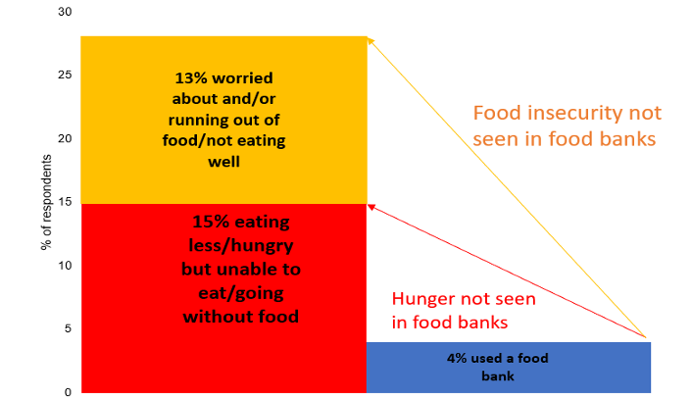

Figure 2: How to End the Need for Food Banks, Infographic by the Independent Food Aid Network. https://ifanuk.org/infographic.

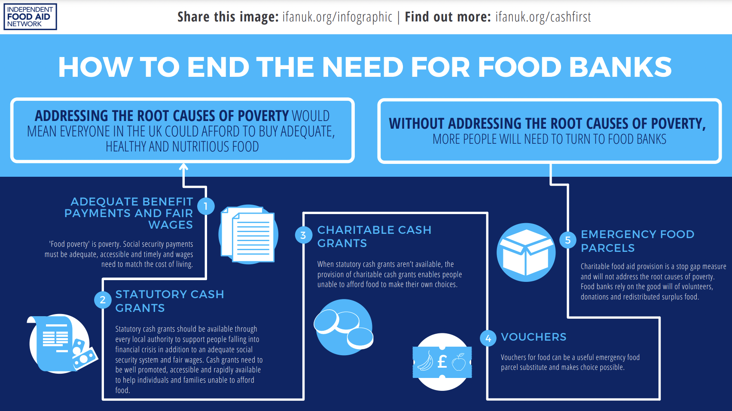

How to End the Need for Food Banks, Independent Food Aid Network. https://ifanuk.org/infographic. Accessed 30.09.22.
Dr Rachel Loopstra et al, A survey of food banks operating independently of The Trussell Trust food bank network, December 2019. https://uploads.strikinglycdn.com/files/0681ad7a-2d07-489f-9c11- 77dc3d1aa968/Report_IndependentFoodBankStudy_Dec2019-pdf.pdf?id=201158. Accessed 01.07.22
The Trussell Trust network alone distributed 1.6 million 3-day food parcels to people from 2018-2019. https://www.trusselltrust.org/2019/04/25/record-1-6m-food-bank-parcels/. Accessed 30.09.22.
See Fig 1 in appendix.
Michael Marmot, Build Back Fairer: The COVID-19 Marmot Review, The Health Foundation, December 2020. https://www.health.org.uk/publications/build-back-fairer-the-covid-19-marmot-review. Accessed 06.07.22.
Structural Inequalities and Food Insecurity Webinar Series Briefing Note #2: Structural Inequality, Disability and Food Insecurity, Independent Food Aid Network, 4th June 2021 https://uploads.strikinglycdn.com/files/d836cd0a-027c-4028-9fd3-8356333a7e2a/FINAL%20040621%20Structural%20Inequality,%20Disability,%20and%20Food%20Insecurity%20(2)%20(2).pdf?id=367453 . Accessed 30.09.22.
IFAN has co-developed cultural and nutritional guidelines for food parcels for the use of their members. 'Nutritional Guidelines for Food Parcels', Independent Food Aid Network. https://www.foodaidnetwork.org.uk/nutritional-guidelines Accessed 30.09.22.
Disabled people are also disproportionately more likely to need the support of a food bank. Structural Inequalities and Food Insecurity Webinar Series Briefing Note #2: Structural Inequality, Disability and Food Insecurity, Independent Food Aid Network, 4th June 2021 https://uploads.strikinglycdn.com/files/d836cd0a-027c-4028-9fd3-8356333a7e2a/FINAL%20040621%20Structural%20Inequality,%20Disability,%20and%20Food%20Insecurity%20(2)%20(2).pdf?id=367453 . Accessed 30.09.22.
Government Food Strategy, Department for Environment, Food and Rural Affairs, https://www.gov.uk/government/publications/government-food-strategy/government-food-strategy Accessed 30.09.22.
National Food Stategy, 2021, https://www.nationalfoodstrategy.org/. Accessed 30.09.22.
Government Food Strategy, Department for Environment, Food and Rural Affairs, https://www.gov.uk/government/publications/government-food-strategy/government-food-strategy Accessed 30.09.22.
For data on Independent Food Banks supporting people who are in work, see: https://www.foodaidnetwork.org.uk/data Accessed 30.09.22.
Survey of Independent Food Banks, August 2022, https://uploads.strikinglycdn.com/files/a31c0c1c-240c-4fa3-b21e-e750b52579dd/IFANSURVEY_August22.pdf Accessed 30.09.22.
This survey was of 84 organisations running 169 independent food banksIFAN, Survey of Independent Food Banks, August 2022, https://uploads.strikinglycdn.com/files/a31c0c1c-240c-4fa3-b21e-e750b52579dd/IFANSURVEY_August22.pdf Accessed 30.09.22.
Family Resources Survey: financial year 2019 to 2020, https://www.gov.uk/government/statistics/family-resources-survey-financial-year-2019-to-2020 Accessed 30.09.22.

